WOUND CARE PROGRAM REFERRAL FORM  PLEASE COMPLETE ALL FIELDS |  |  | 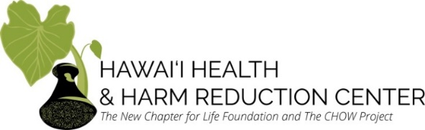
Fax Referral Form to (808) 521-1552 (Attn: Christina Wang) Phone: (808) 683-5484
Today's date: | Is this person a current HHHRC participant? Y / N |  |  |  |  | HHHRC SEP participant card #:
Patient's name: |  |  |  |  |  | Date of birth:
Address or other location where patient can generally be found:

Primary phone #: |  | Other means of contact:
Referring Information
Referral source: Queens ED Queens Wound Care IHS Straub HOME clinic Other: ___________________________
Name of referrer: |  | Phone #: |  |  | Fax # or email:
PCP (if any): |  | Phone #:
Health Insurance Information
Primary insurance: |  | Subscriber: |  |  | Sub ID:
Secondary insurance: |  | Subscriber: |  |  | Sub ID:
Diagnosis and Pertinent Medical History
ICD-10 diagnosis codes: |  |  |  | A & O Status:
Is the patient able to ambulate independently? Y / N If no, what assistive devices are used? _______________________
Information about wounds (wound location(s), size(s), and duration; previous treatments that have been tried, etc.): {Please feel free to attach recent SOAP note/progress notes and other pertinent information}

If the wound is on an extremity, is patient being seen by a vascular surgeon? |  |  |  |  | Y / N
Is the wound on a surgical site (ie amputation stump)? |  |  |  |  | Y / N
Name of surgeon: |  | Date of surgery: |  |  | CPT Code(s):
Labs/imaging in the past 2 months, particularly Prealbumin, A1C, and vascular studies:

* Please inform us if patient has a history of the following: ___ MRSA ___ VRE ___ ESBL ___ C. Diff

Additional Information About the Hawaiʻi Health & Harm Reduction Center Community-Based Wound Care Program
HHHRC’s community-based wound care program is for basic wound care that can be managed in a community setting, which includes, but is not limited to:
- The Hawaiʻi Health & Harm Reduction Center’s wound care program does not have the capacity to care for long-term bedridden patients.
- Patients appropriate for outpatient setting needing follow-up
- Simple I&Ds that were performed at the bedside and/or were discharged from the ED
- Wounds that do not require IV antibiotics
- Dressing changes with discharge orders.
If there are any questions or concerns, please contact Christina Wang, DNP, MPH, APRN-Rx, AGPCNP-C at
808-683-5484 to clarify whether this patient can be managed in a community setting.
HHHRC Clinic: 677 Ala Moana Blvd Suite 226 Honolulu, HI 96813
Clinic Hours: Monday, Wednesday, Thursday 9:00am - 4:30pm, Tuesday and Friday 1:00pm - 4:30pm
HHHRC Chinatown Outreach (on River and Kukui): Tuesday and Friday 9:00am - 12:00pm

