SUBSTANCE USE DISORDER REFERRAL FORM
PLEASE COMPLETE ALL FIELDS
or attach face sheet, H & P Labs, and D/C Summary
Form available on www.hhhrc.org
Fax Referral Form to (808) 521-1552 (Attn: Dr. Christina Wang) Phone: (808) 521-2437
Patient's name: |  |  |  |  |  |  |  | Date of Birth:
Address or other location where patient can generally be found:

Primary phone #: |  |  |  | Other means of contact:
Referring Information
Referral source: | Castle | Kahuku |  |  | Kapiolani | Kuakini |  |  |  | Pali Momi | Straub
 | Queens | Wahiawa |  |  | Waianae Comprehensive |  |  |  |  | Other: ________________________
Name of referrer: |  |  |  | Phone #: |  |  |  | Fax # or email:
PCP (if any): |  |  |  | Phone #: |  |  |  | Fax # or email:
Health Insurance Information
[Please note some insurance companies require Prior Authorizations for Buprenorphine]
Primary insurance: |  |  |  | Subscriber: |  |  |  | Sub ID:
Secondary insurance: |  |  |  | Subscriber: |  |  |  | Sub ID:
Diagnosis and Pertinent Medical History
ICD-10 diagnoses codes: |  |  |  |  |  |  |  | A & O Status:
Is the patient able to ambulate independently? Y / N If no, what assistive devices are used? _________________
Recommended ED screening order Set: *or attach labs
- UDS results:
- Patient currently on Methadone? Y / N Medication Reconciliation Allergies?
- Pregnancy screening (if needed): Y /N Results:
- HIV, Hep A, B, C panels
- LFTs
-COWS (Clinical Opiate Withdrawal Scale) Assessment Tool
-Vital Signs
Please circle one:
- Inducted in ED 2) Advised for home induction then follow up 3) Outpatient assessment & /or induction
Additional Information About the Hawaiʻi Health & Harm Reduction Center
We are a non-profit clinic focusing patient care on evidence-informed harm reduction principles. We offer a variety of services and welcome all people for care without regard to insurance status or ability to pay.
* The Hawaiʻi Health & Harm Reduction Center’s wound care program does not have the capacity to care for long-term bedridden patients.
- Community based wound care (referral form at www.hhhrc.org)  - Addiction Medicine Services |  |  | - Psychiatric Services  - Rapid HIV/ HCV testing  - HIV Case Management |  |  |  |  |  | - HCV treatment  - PrEP/ PEP / STI testing  - Smoking Cessation Counseling
HHHRC Clinic: 677 Ala Moana Blvd Suite 226 Honolulu, HI 96813 Phone: (808) 521-2437 Website: www.hhhrc.org
Clinic Hours: Monday, Wednesday, Thursday 9:00am–4:30pm, Tuesday and Friday 1:00pm–4:30pm (Walk-ins Welcome)
HHHRC Chinatown Outreach (on River St. & Kukui St.): Tuesday and Friday 9:00am–12:00pm

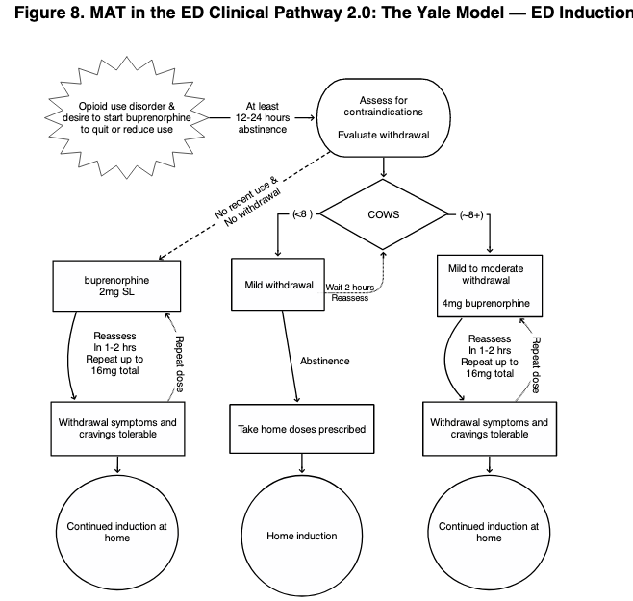
(Herring, A.A. 2016)
Other considerations: Safety, Driving, Storage?
*Adjunct withdrawal meds to Rx:
Clonidine 0.1 mg PO q4 hrs PRN
Loperamide 4mg PO PRN up to 16 mg QD
Ibuprofen 400 mg PO q6 hrs and/ or Gabapentin 600 mg PO TID

